



<View>: is used to structure and organize content

<Text view >: will be used to display the “Culinary courier “text

<Text view >: will be used to display the “cooking like a boss “ text

<background image >: To make the application presentable

<Button> : The sign in button to navigate the user to the sign in page

<Button >: The log in button to navigate the user to the log in page

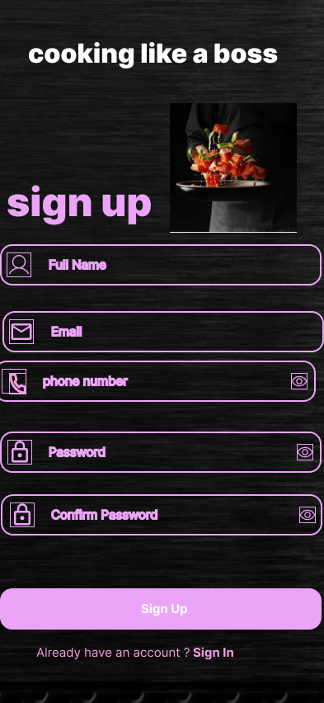

Name input : <TextInput> for users to enter their full name

Email input :< TextInput> for users to enter their full name

Phone number : <TextInput>For the phone number input field

Password input :<TextInput>users to enter a password securely

Confirm password :<TextInput> with a secureTextEntry To insure that the user enter their password correctly

Sign up :<Buttons> it will allow the user to take action to submit the information provided by the user

<Text view> : for the already have account text ?

<image> to give visual elements to the page

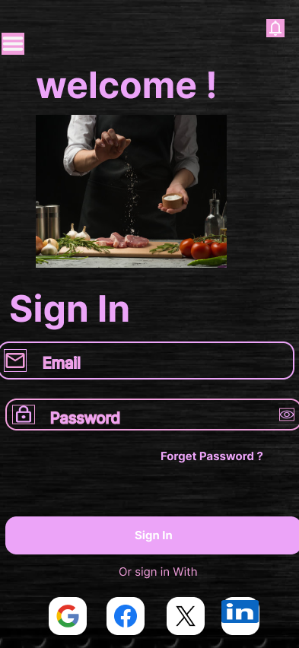

<Text > : welcome text

<text >:sign in

Username input use <TextInput>for user to type their email

Password input use ,<TextInput> with the secureTextEntry for password field to keep password hidden

<Text >: forget password text

<Text >: sign in with text

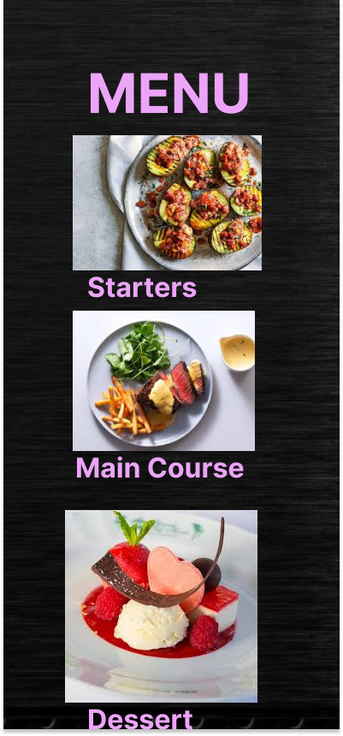

<picker> allows the user to be able to choose the menu

<text>menu text

<text> starter text

<text>main course text

<text>dessert

<Image >to visual elements

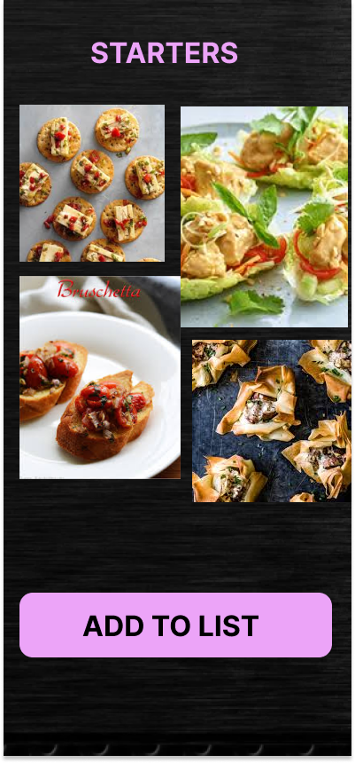

<text> starters text

<button>allows the user to add to the list by clicking the button

<Image>visual element

<Image>visual element

<Image>visual element

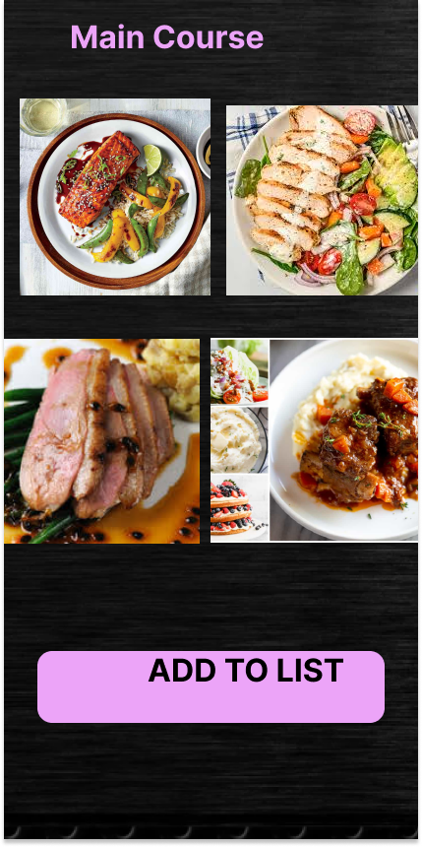

<text> main course text

<button>allows the user to add to the list by clicking the button

<Image>visual element

<Image>visual element

<Image>visual element

<text> dessert text

<button>allows the user to add to the list by clicking the button

<Image>visual element

<Image>visual element

<Image>visual element

<text>Dish information

instruction ingredients input use <TextInput>chef to enter the dish ingredients

perparation time input use <TextInput>for chef to enter the peration time

instruction input use <TextInput>cheft to enter the dish instructions

serving size input use <TextInput>chef to enter the serving size

price input use <TextInput>chef to enter the dish price

<button> save button to store the information from the user

<button> cancel button to erase the information from the user